“The best moments in life are captured with a photo or remembered by a song, so it was key for the HTC One series to improve these emotional experiences with an amazing camera and authentic sound experience. We are very focused on creating a camera and audio experience customers will love and use often and we believe the HTC One series delivers this in a way never seen on a phone before.”
- Peter Chou, CEO of HTC Corporation

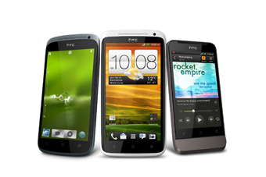
HTC, a smartphones giant, unveiled its new HTC One series of smartphones that represent its most premium mobile experience.
HTC One™ accentuated by an Authentic Sound Experience and Amazing Camera Unprecedented momentum for HTC One series – available in the beginning of April with broad global availability through more than 140 mobile operators and distributors.
With HTC’s most premium experience, the HTC One series integrated with the Android 4.0 (ICS) with HTC Sense™ 4, the new version of HTC’s branded user experience that is introducing HTC ImageSense™, a new league of camera and imaging features that set HTC One apart. HTC Sense 4 also includes broad enhancements to audio quality and simplifies how people listen to music on their phone.
Amazing Camera
With ImageSense HTC One rival’s traditional digital cameras with improvements to every part of the camera, including the lens, the sensor, the software, and even integrating a new custom HTC ImageChip. These enhancements together deliver the fastest image capture, best image quality under adverse conditions and easiest interface which enables quick access to capturing stills and videos with side-by-side photo and video capture buttons.
- Superfast Capture - HTC One dramatically reduces the time it takes to capture those key moments. In just 0.7 seconds you’re able to take a shot, and with a new superfast 0.2-seconds autofocus, continue to take nearly unlimited continuous shots simply by holding the shutter button.
- Good photos in adverse conditions - HTC One includes HDR, a market-leading technology, for taking great photos even when there are varying levels of brightness. HTC One delivers dramatic enhancements in image capture quality even in adverse conditions such as low light, no light or with bright backlighting. The f/2.0 lens on the HTC One X and HTC One S offers best-in-class performance, capturing 40 percent more light than the f/2.4 lenses available on other high-end phones.
- Video Pic (Concurrent Video/Still Capture) – With Video Pic you capture a photo and shoot video at the same time, all you have to do is tap the shutter button and it snaps a high-resolution still photo while the video continues to shoot. You are also able to capture a photo frame from a previously recorded video.
- Dropbox integrated with HTC Sense - HTC One gives you an easy way to save and share your photos and videos. HTC has integrated Dropbox into HTC Sense 4 enabling HTC One customers to get 25 gigabytes of free Dropbox space for two years. Dropbox is also integrated throughout HTC Sense 4, so it’s easy to edit, save and share your documents and other kinds of files.
- Sharing your photos and more - HTC One gives you a new way to share your photos and videos. When you plug in HTC’s wireless Media Link HD accessory into your TV’s HDMI port, you can easily share your photos, videos, or anything else on your phone with your friends, family or colleagues regardless of the television’s brand as long as it has HDMI.

Authentic Sound
With HTC One, Beats By Dr. Dre Audio™( Beats By Dr. Dre is a brand of headphones and loudspeakers marketed by hip-hop/rap artist Dr. Dre and Interscope-Geffen-A&M Records chairman Jimmy Iovine under Beats Electronics, LLC.) integration is enabled for the first time across the entire experience for richer, more authentic sound whether you’re listening to your favorite music, watching a YouTube™ video or playing a game. HTC One also makes it easy to get and listen to your music on your phone with the built-in HTC Sync Manager software that automatically installs to your computer when connected. Once connected, it is easy to transfer songs, artists and playlists from your music library.
Of course, people today no longer just listen to the songs stored on their phones; they use streaming services and tune into Internet radio. So HTC One lets you customize the new Music Hub with your favorite services and music applications, like the latest Soundhound technology, giving you one place to go for all of your music.
HTC One lets you take all of your music anywhere, including the car. With HTC One, you get an easy way to bring your mobile music to your car’s sound system with the HTC Car Stereo Clip. It also lets you connect to your music through more than 50 thousand online radio stations worldwide or play music from any service or app on your phone through your car speakers. All this makes HTC One the one place to enjoy all your music, wherever you are, with the power of Beats by Dr. Dre Audio and HTC Car.
HTC One X
The HTC One X portrays a beautifully crafted polycarbonate unibody that has the strength and rigidity of metal but is super lightweight. With seamless construction, the unibody combines a unique high gloss 'piano' finish and a matte back. HTC One is blazing fast with the new NVIDIA® Tegra 3 Mobile Processor for clear graphics, faster applications and longer battery life. It includes a 1.5GHz Super 4-PLUS-1™ quad-core with an integrated fifth Battery Saver Core and a high-performance 12-Core NVIDIA® GPU. The HTC One also savors a startling 4.7-inch, 720p HD screen crafted from contoured Corning™ Gorilla Glass.
Your quad – core powered entertainer 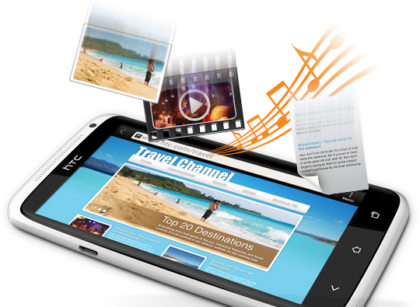
Out of the world quad-core power gives you lightning-fast web browsing, remarkable picture quality and extraordinary gaming effects --all on a giant, 4.7-inch HD screen.
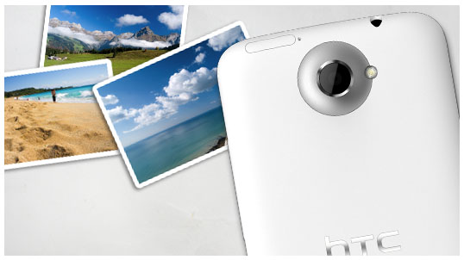
A camera so good, you might need a reminder that it’s also a phone
This is a true digital camera on your phone. It easily handles low light settings and turns action shots into crisp photos, thanks to the HTC ImageChip.
Music, the way it was originally recorded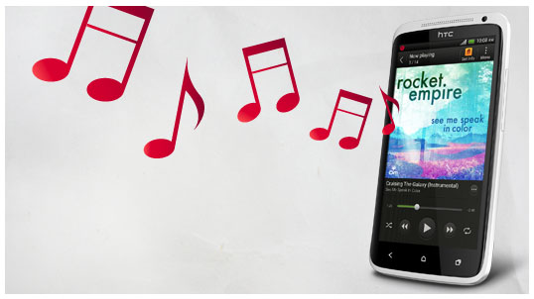
With Beats Audio, listening is different. It's a deep, finely-detailed sound; the actual sound the artist hears in the recording studio--and what they want you to hear.
Dropbox integration
Never worry about attachments again – simply share large files by sending a Dropbox link. Plus, access your Dropbox straight from the Polaris Office app to edit documents, spreadsheets, and presentations and save them back automatically.

HTC One S
The HTC One S is for people who want a high-end smartphone in compact size of a regular mobile. It is powered by a Qualcomm Snapdragon S4 processor with up to 1.5GHz dual-core CPU’s. It also includes a 4.3-inch screen thrown together from contoured Corning™ Gorilla Glass. HTC One S brings HTC’s innovative metal unibody styling to a new thin 7.9-mm design, making it HTC’s thinnest phone yet. The HTC One S sports two new finishes that break new ground in mobile phone innovation. The first is an ultra-matte black Ceramic Metal surface that is the result of a microarc oxidation (MAO) process originally developed for use in satellites. It transforms the surface of the aluminum unibody into a ceramic, super-dense crystalline structure that is four times harder than anodized aluminum, enabling the HTC One S to look great over time. The second finish for the One S takes anodizing to a new level with a new patented process that creates a light-to-dark gradient fade that looks gorgeous and sophisticated.
Beauty and brains 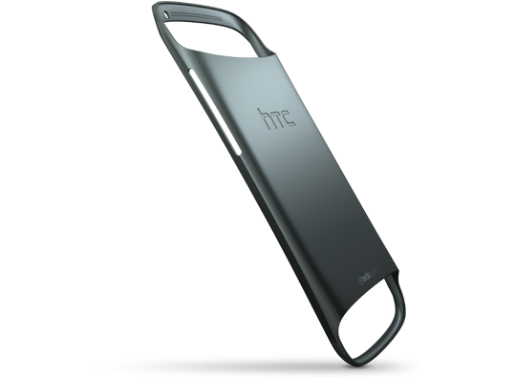
Capture stunning photos with a stunning phone. This true digital camera gives you realistic colors and dependable performance with features such as auto smile detection, face focus and continuous shooting. With this phone in your hands you can capture every special moment, wherever you go, in pictures as stunning as its own great looks.
All-encompassing entertainment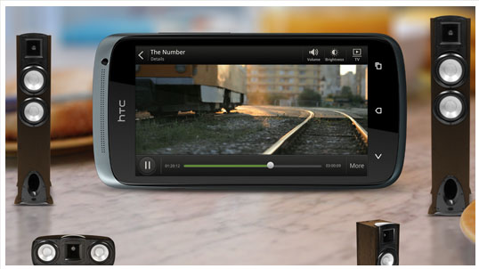
Enjoy sound like never before thanks to the range of Beats Audio: from thundering bass to crisp highs. Plus movies and videos look extra sharp on the 4.3-inch qHD display.

Every photo. Every time. 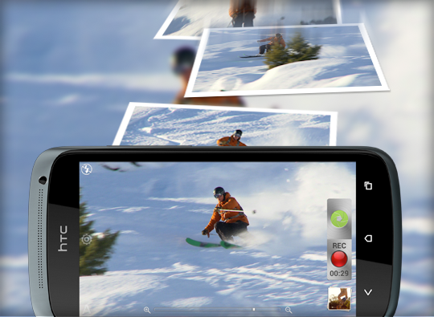
This is a true digital camera. It's ready for instant action in any setting and HTC ImageSense technology delivers brilliantly detailed photos. Count on rich, accurate colors, auto smile detection and face focus. You can even snap a picture while shooting HD video.

HTC One V
Forged from the classic, award-winning design of the HTC Legend, the HTC One V brings top-end design to a smartphone with broad appeal and a premium experience that delivers an amazing camera and authentic sound. It features a simple, iconic aluminum unibody design that exudes craftsmanship and quality.
The essential smartphone
It’s the first thing you pick up in the morning, and the last thing you put away at night. You work on it, you connect to the digital world with it, and you interact with those that matter most on it. You reach for it every time you want to remember a moment, and you easily share that moment with just a couple taps. This isn’t just another smartphone; it stays with you and keeps up with you. HTC One V, the essential smartphone for those on the go.
Best in class camera for instant capture and low light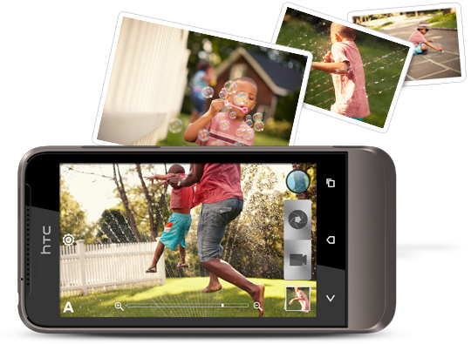
Activate your camera and take that special shot- all under 1 second. That’s the promise that the HTC One V delivers. Not in an ideal lighting location for great pictures? Be amazed as HTC One V has all the latest in digital technology to ensure you have the brightest, clearest shot possible.
Looks great, works even better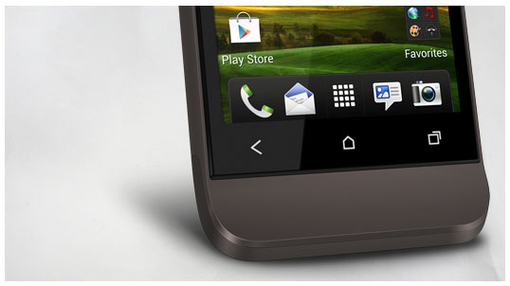
The HTC One V is designed with a metal-unibody architecture that’s cool to the touch and durable. The One V also holds a slightly curved chin for an iconic look, but also makes it easier for messaging. Even the screen, premium looking and a delight to the eyes, is made out of reinforced glass and is scratch resistant. Designed to look great while working for you, from the inside out.
Authentic Sound 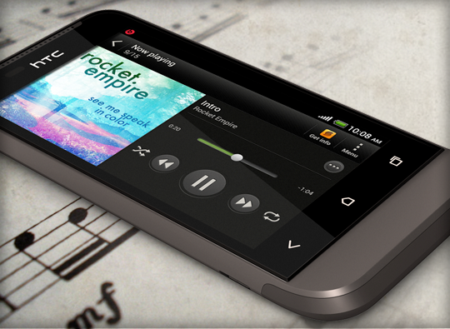
Bringing you right into the recording studio, Beats Audio through your HTC One V will optimizes any type of music played. You will experience music as the artist intended. Playing a video, or gaming? Beats Audio extends to any kind of media played, feel immersed through the rich, premium sounds that enhance any type of entertainment.
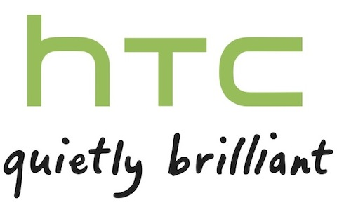
SPECS:
Phones | HTC One X  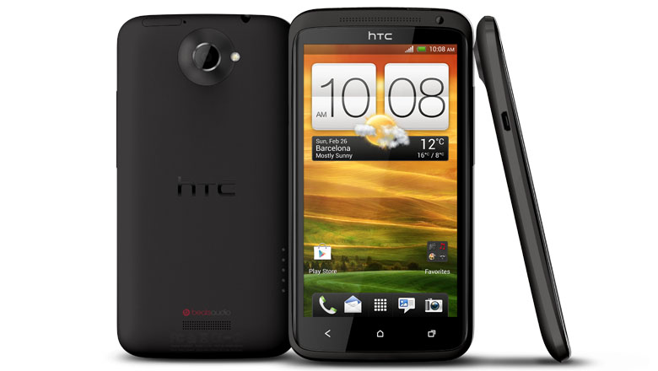 | HTC One S  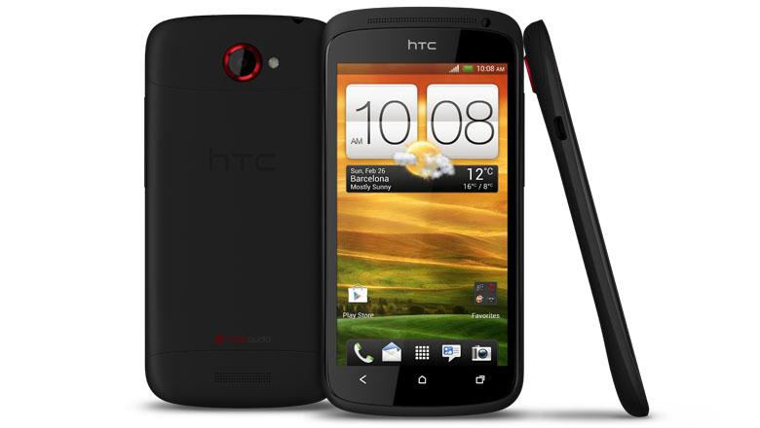 | HTC One V  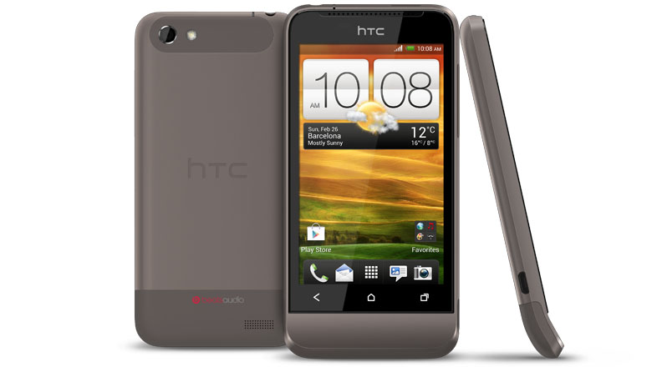
Size | 134.36 x 69.9 x 8.9 mm | 130.9 x 65 x 7.8 mm | 120.3mm x 59.7mm x 9.24mm
Weight | 130 grams with battery | 119.5 grams with battery | 115 grams with battery
Display | HD 720p touch | 4.3-inch touch screen | 3.7-inch touch
Screen | 4.7-inch (1280 x 720 resolution) | 4.3-inch (540 x 960 resolution) | 480 x 800 resolution
CPU | 1.5 GHz, quad core | 1.5 GHz, dual core | 1 GHz
Platform | Android™ 4.0 with HTC Sense™ 4 | Android™ 4.0 with HTC Sense™ 4 | Android™ 4.0 with HTC Sense™ 4
Memory | Total storage : 32 GB  RAM:1 GB | Total storage: 16GB  RAM: 1 GB | Total storage: 4 GB  RAM: 512 MB  Expansion slot:  - microSD™ memory card (SD 2.0 compatible)
Connectivity | - 3.5 mm stereo audio jack  - NFC₃  - Bluetooth with aptX™ enabled (Bluetooth® 4.0)  - Wi-Fi®: IEEE 802.11 a/b/g/n  - DLNA® for wirelessly streaming media from the phone to a compatible TV or computer  - Micro-USB 2.0 (5-pin) port with mobile high-definition video link (MHL) for USB or HDMI connection (Special cable required for HDMI connection.) | - 3.5 mm stereo audio jack  - Bluetooth with aptX® enabled (Bluetooth® 4.0)  - Wi-Fi®: IEEE 802.11b/g/n  - DLNA® for wirelessly streaming media from the phone to a compatible TV or computer  - Micro-USB 2.0 (5-pin) port with mobile high-definition video link (MHL) for USB or HDMI connection (Special cable required for HDMI connection.) | - 3.5 mm stereo audio jack  - Bluetooth with aptX® enabled (Bluetooth® 4.0)  - Wi-Fi®: IEEE 802.11b/g/n  - Standard micro-USB (5-pin micro-USB 2.0)
Camera | - 8 megapixel camera with auto focus, smart LED flash, and BSI sensor (for better low-light captures)  - F2.0 aperture and 28mm lens  - 1080p HD video recording  - 1.3 megapixel front camera (720p for video chat)  - Dedicated imaging chip  - Capture a photo in the midst of recording HD video  - Continuous shooting mode captures multiple snapshots  - Auto flash smartly determined by distance from your subject  - Video stabilization feature removes annoying, shaky motion  - High quality slow motion video capture and playback | - 8 megapixel camera with auto focus, smart LED flash, and BSI sensor (for better low-light captures)  - F2.0 aperture and 28mm lens  - 1080p HD video recording  - VGA front camera  - Dedicated imaging chip  - Capture a photo in the midst of recording HD video  - Continuous shooting mode captures multiple snapshots  - Auto flash smartly determined by distance from your subject  - Video stabilization feature removes annoying, shaky motion  - High quality slow motion video capture and playback | - 5 megapixel camera with auto focus, smart LED flash, and BSI sensor (for better low-light captures)  - F2.0 aperture and 28mm lens  - 720p HD video recording  - Dedicated imaging chip  - Capture a photo in the midst of recording HD video  - Continuous shooting mode captures multiple snapshots
Sound | Beats Audio™ | Beats Audio™ | Beats Audio™
Battery | Capacity :1800 mAh | Capacity: 1650 mAh | Capacity: 1500 mAh

